Table of Contents

Gotoro: Guideline to Setup LB for BE 1

Gotoro: Guideline to Add route rule for Jenkins 1

# Gotoro: Guideline to Setup LB for BE

Step 1: Login Oracle Cloud: [Oracle Cloud Infrastructure](https://cloud.oracle.com/?region=us-ashburn-1). Go to **Compute** > **Instances**.

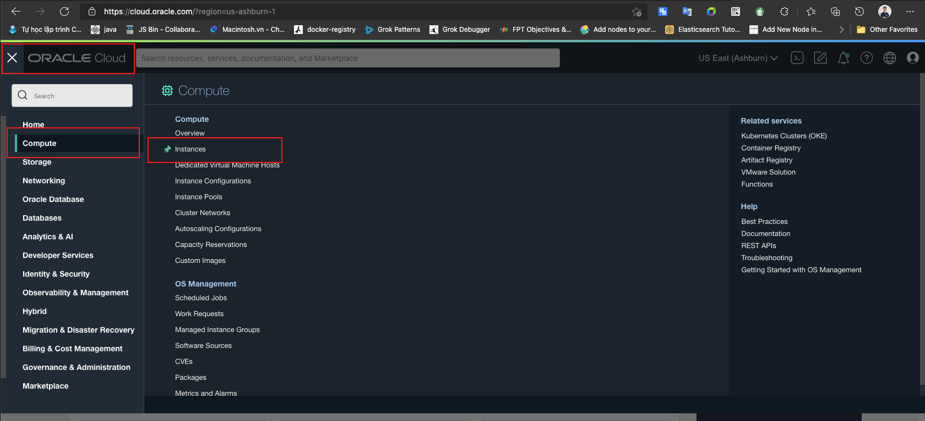

Step 2: Chose **Compartment** for your environment and **get Gotoro-Application IP**.

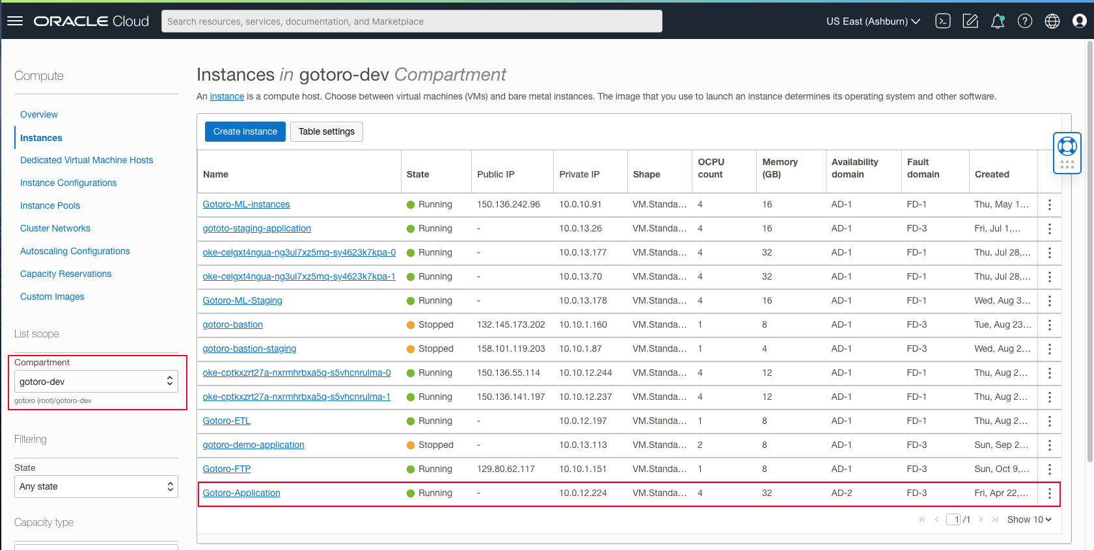

Step 3: Go Networking > Load Balancers

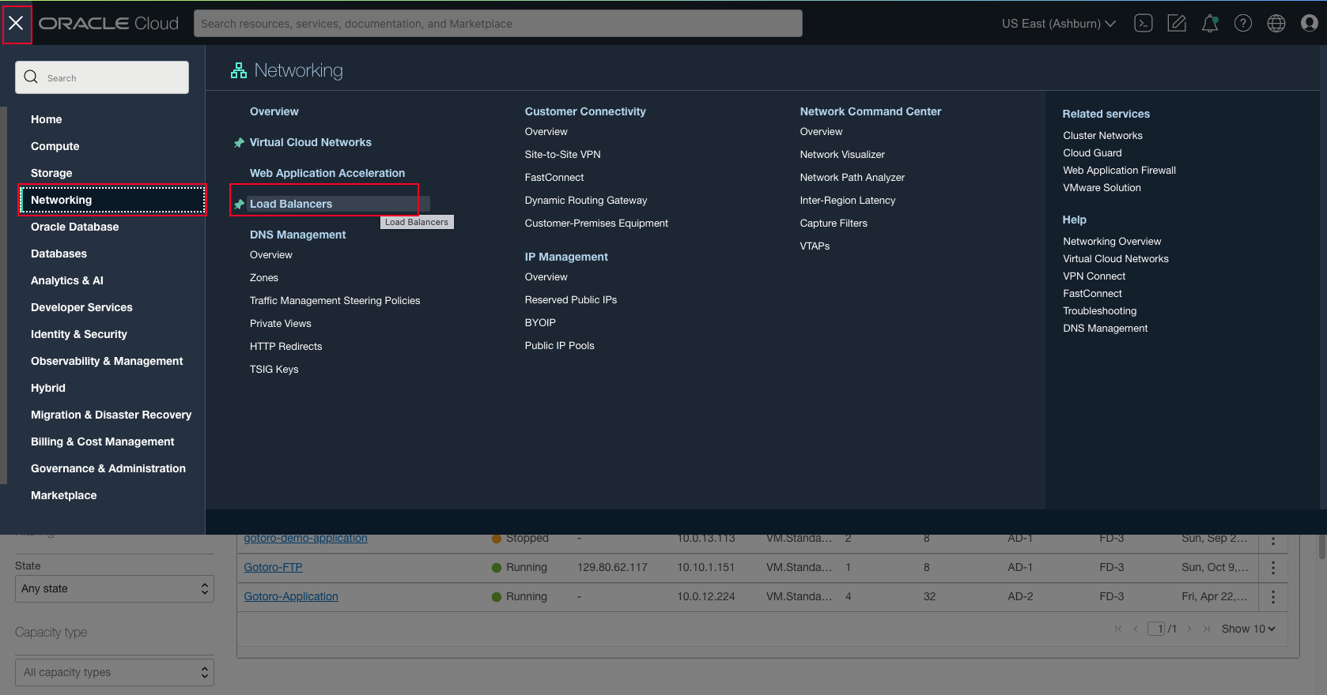

Step 4: Chose Comparment and Create Load Balancer

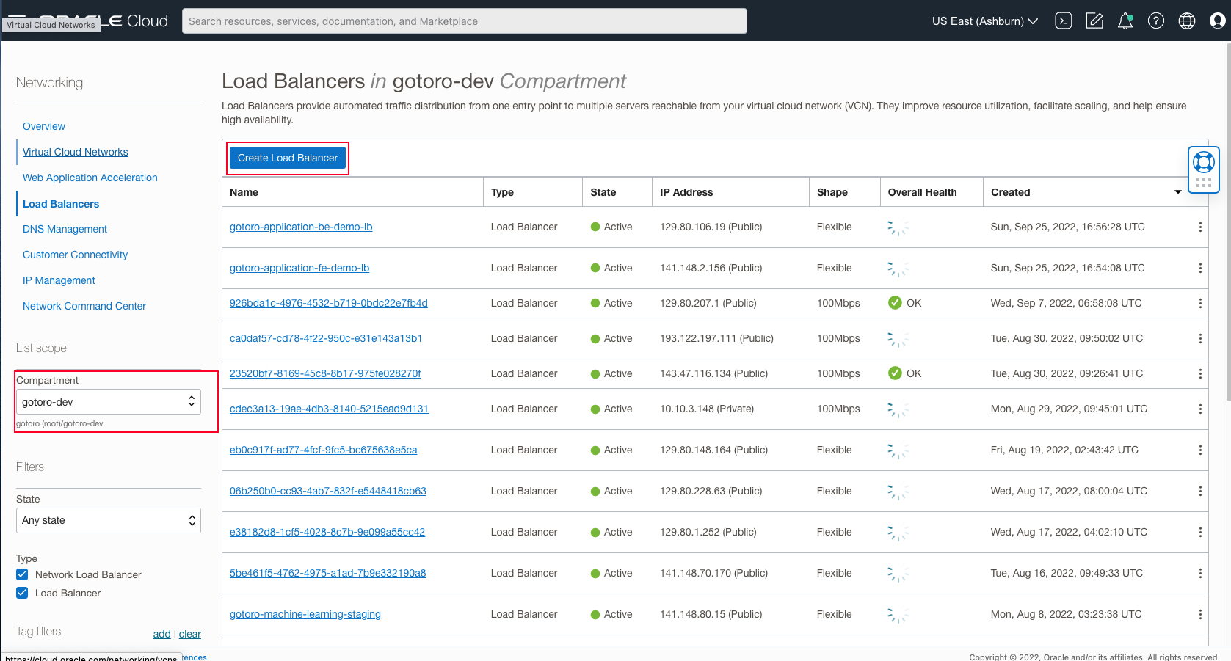

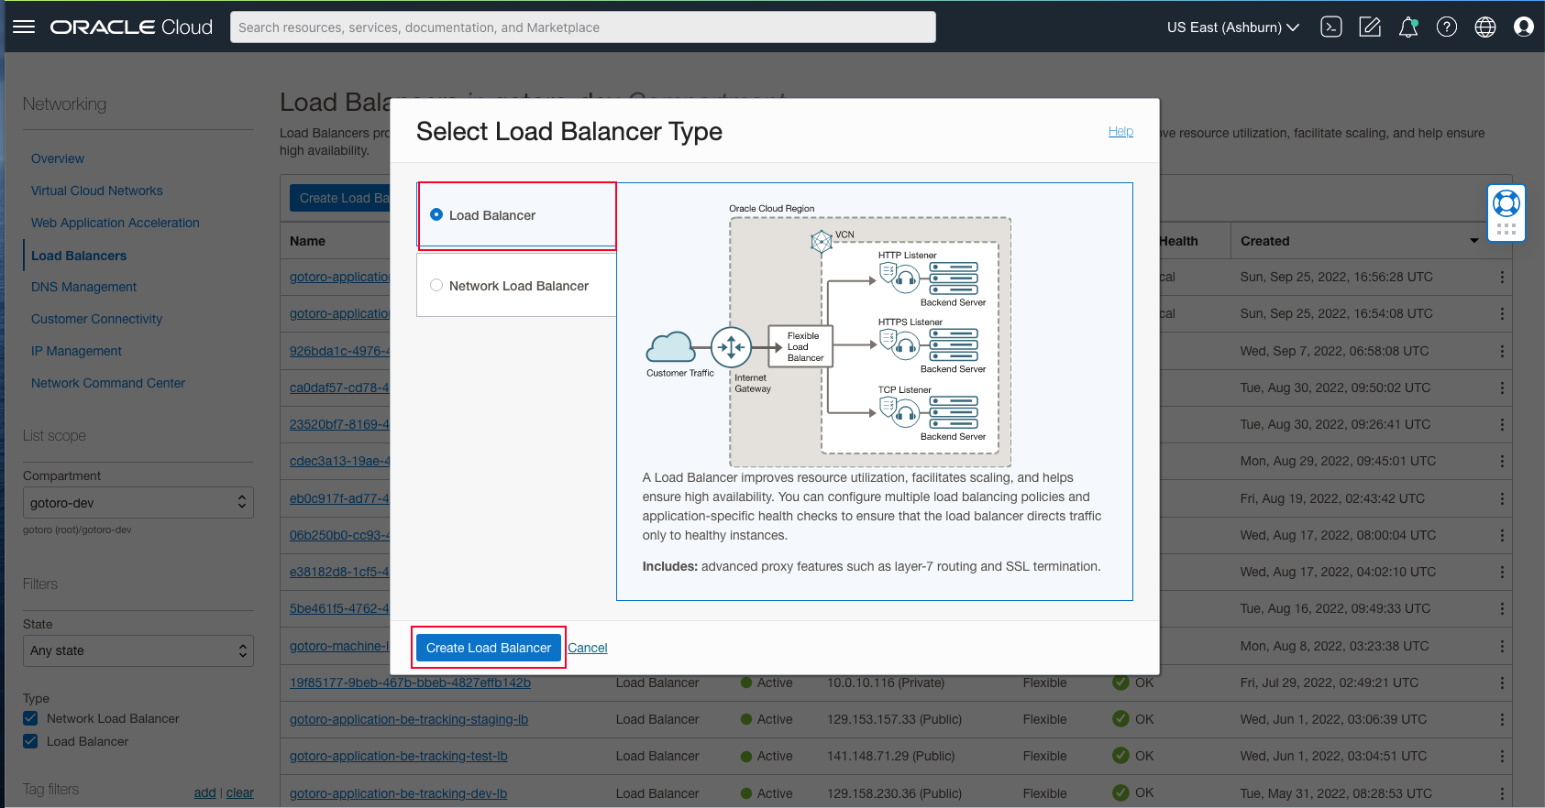

Step 5: Add Details.

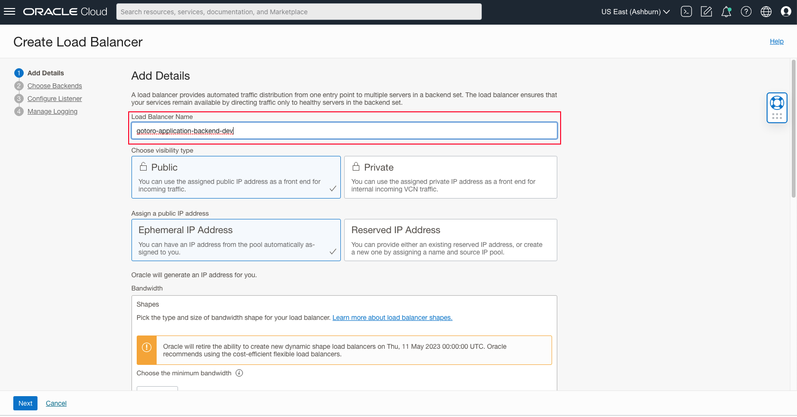

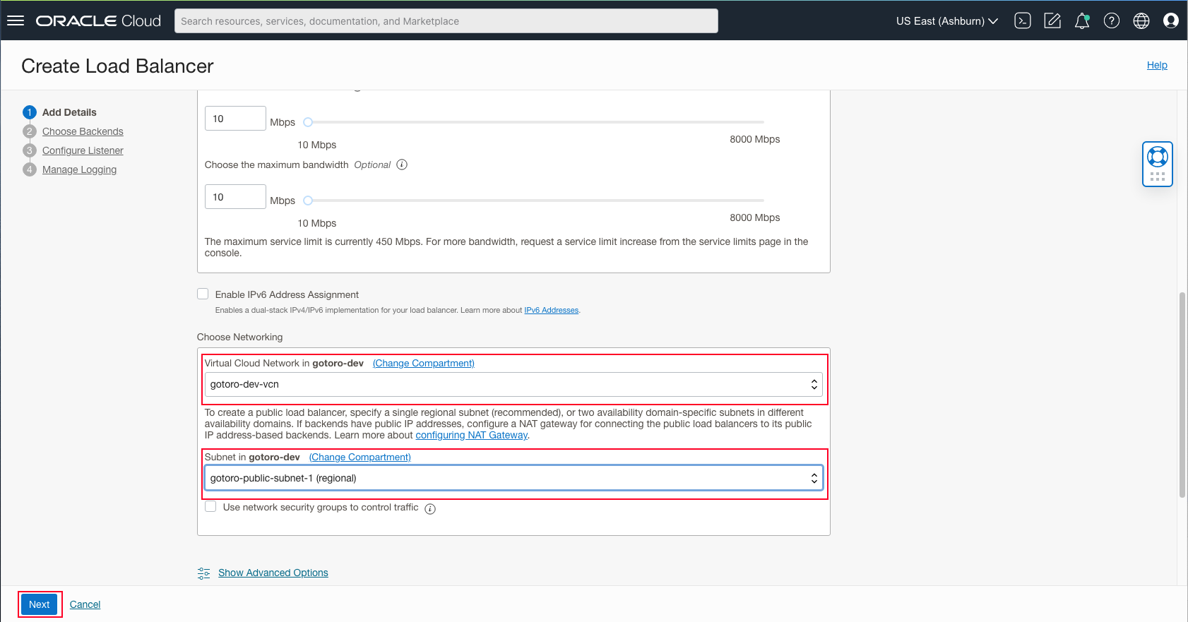

Step 6: Chose Backends

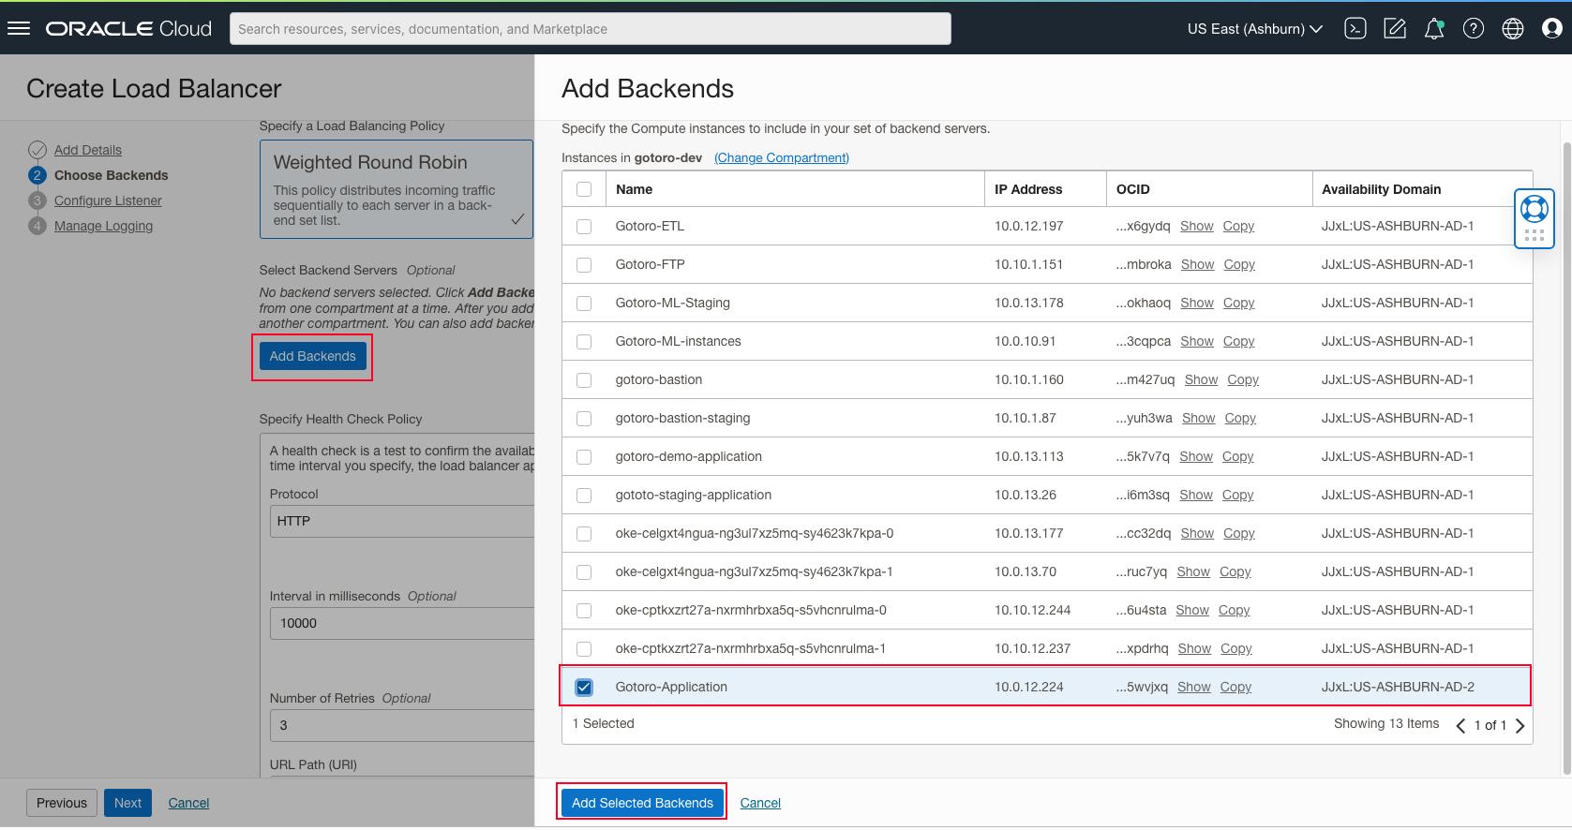

Step 7: Update Health check

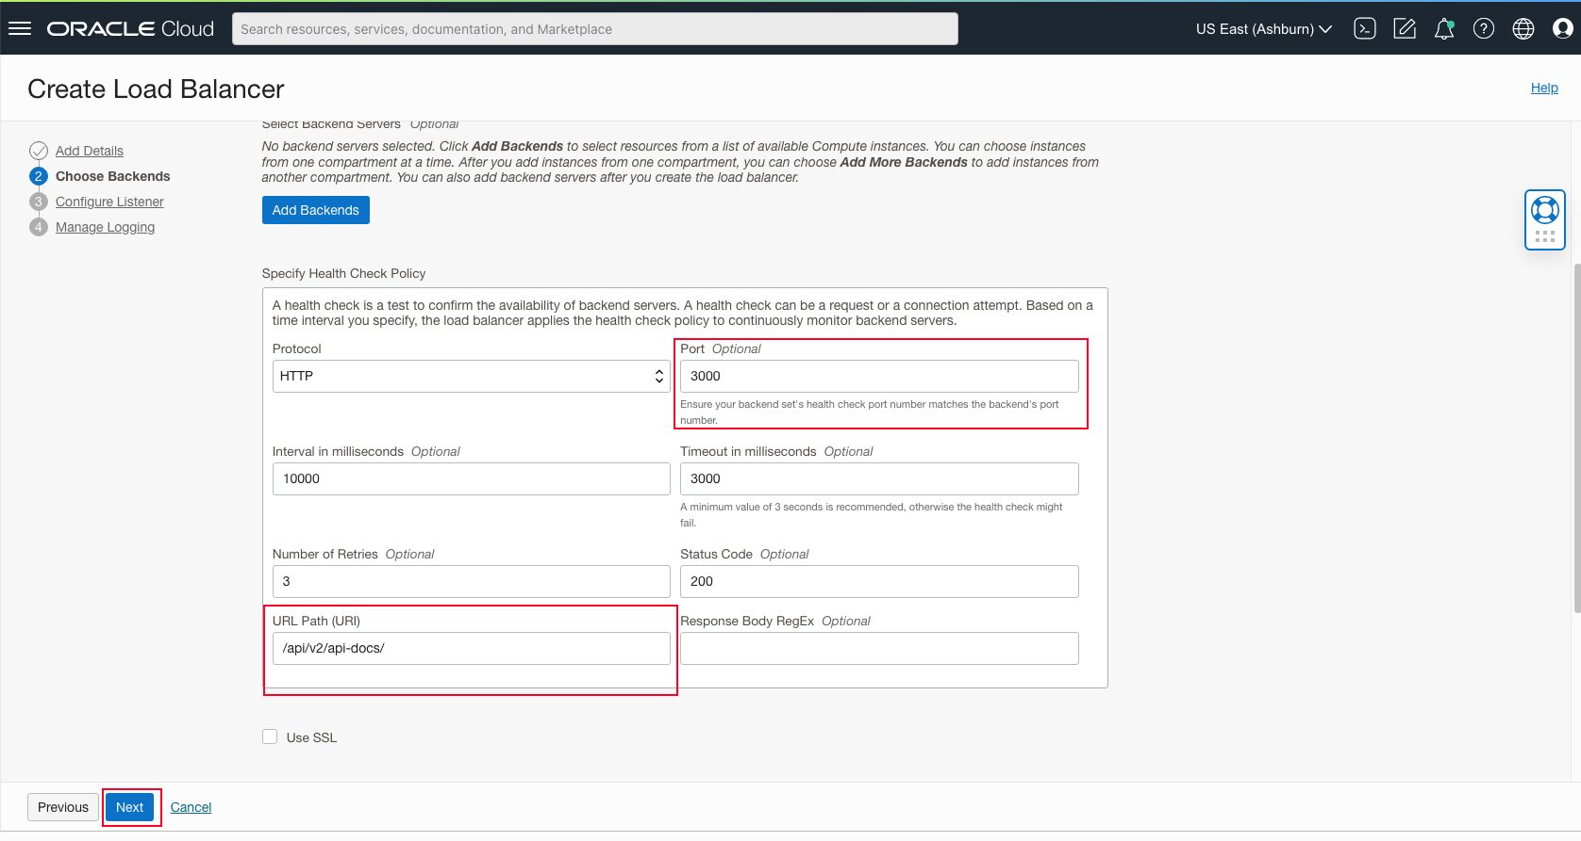

Note: Get port form docker-compose.yml file.   
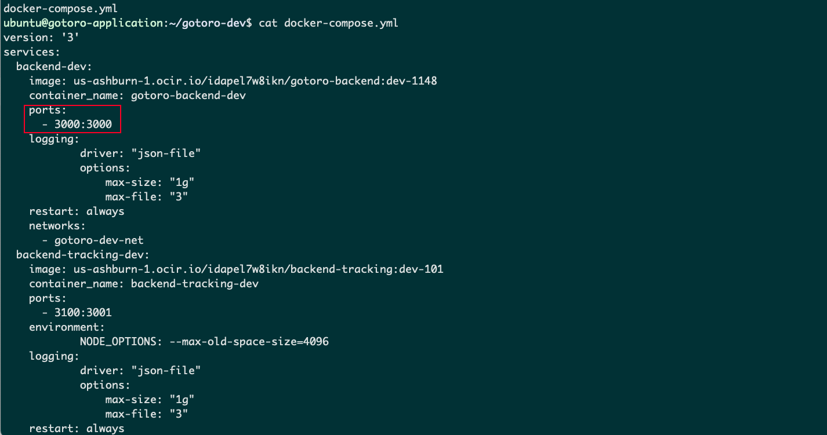

Step 8: Config Listener

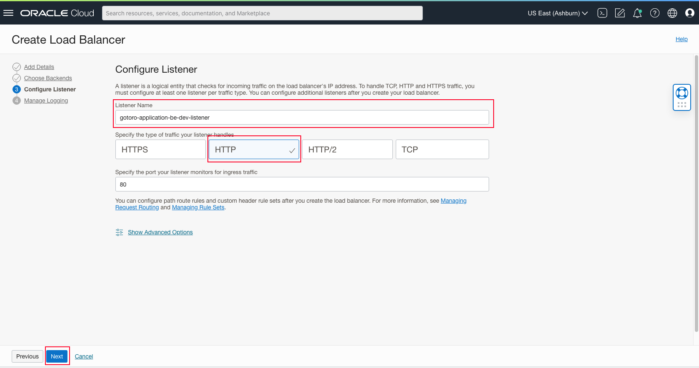

Step 9: Manage Loging

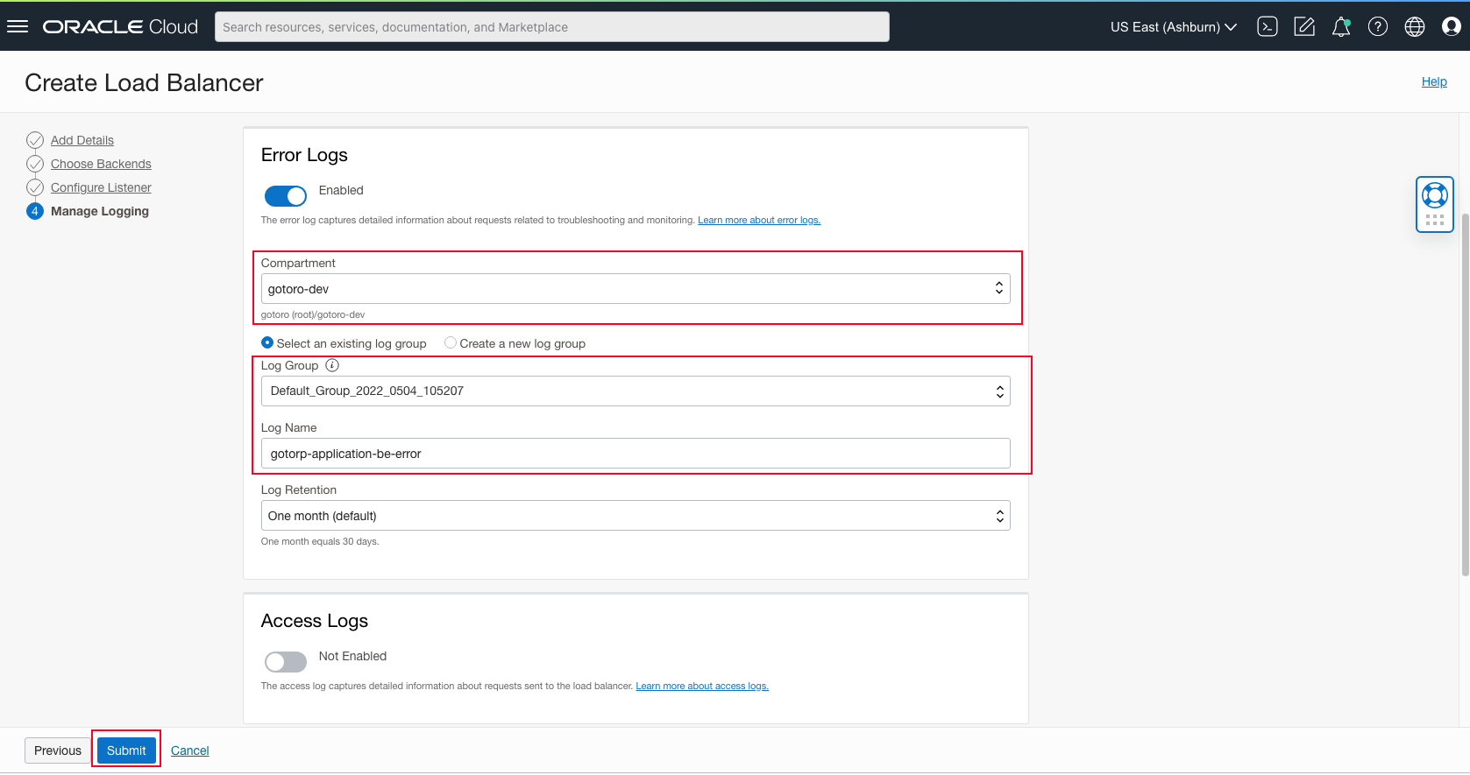

Submit

# Gotoro: Guideline to Add route rule for Jenkins

Step 1: Go Networking > Load Balancers



Step 2: Change **Compartment** to devops and Chose Jenkins LB

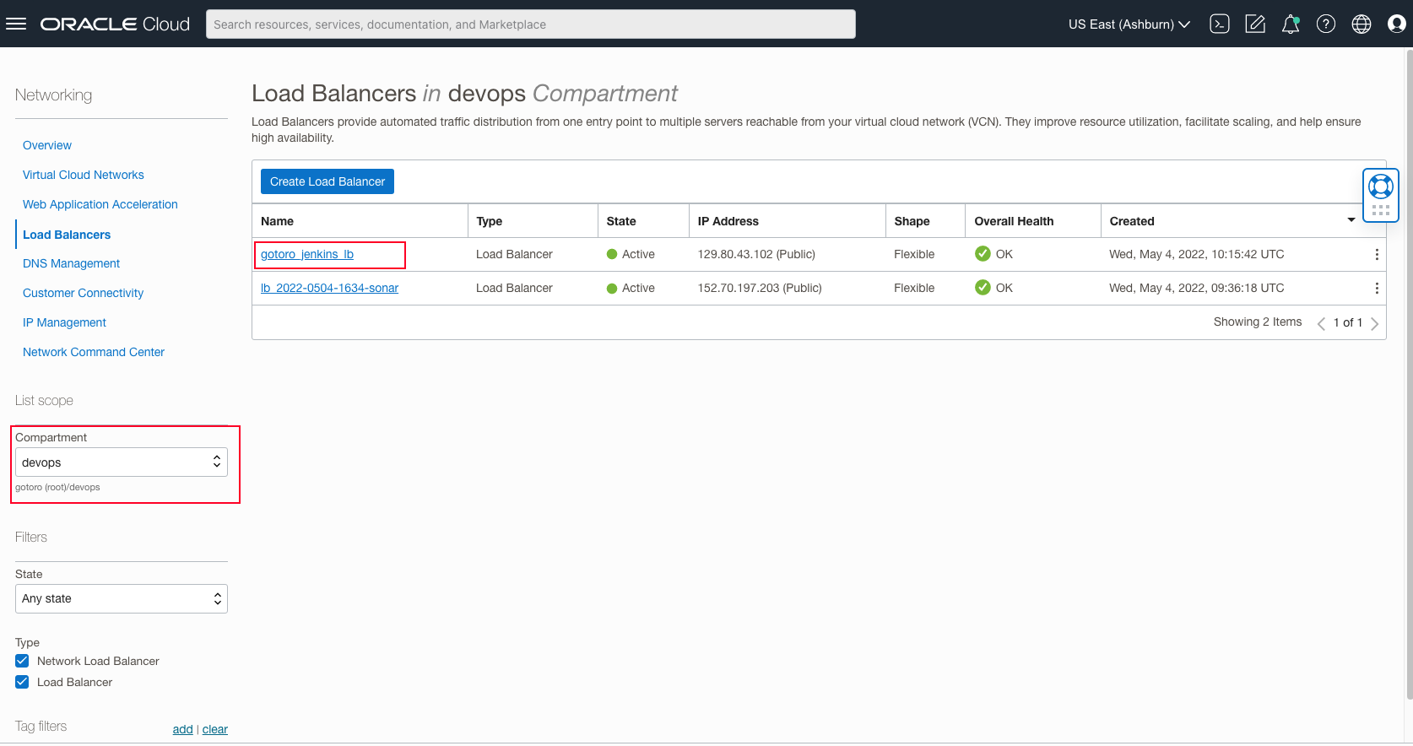

Step 3: Chose Routing policy.

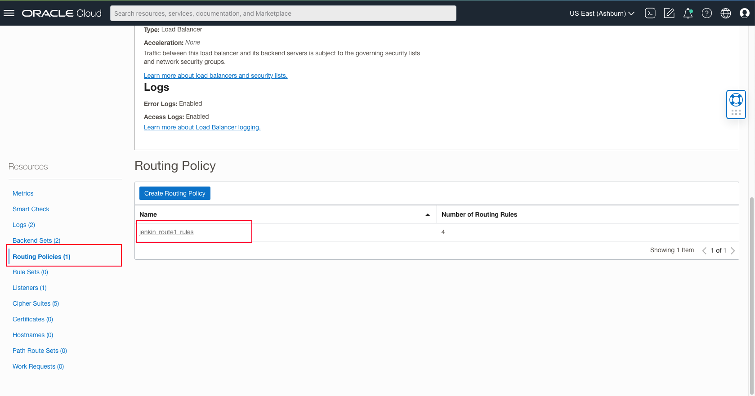

Step 4: Add Another Rule

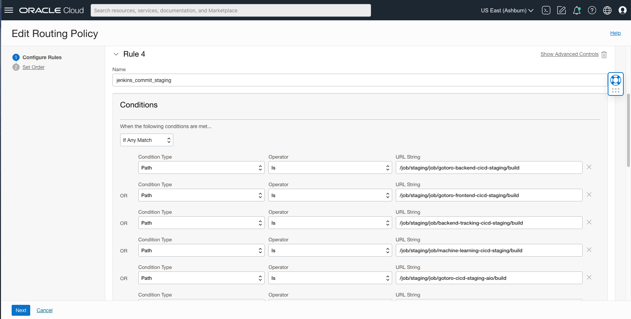

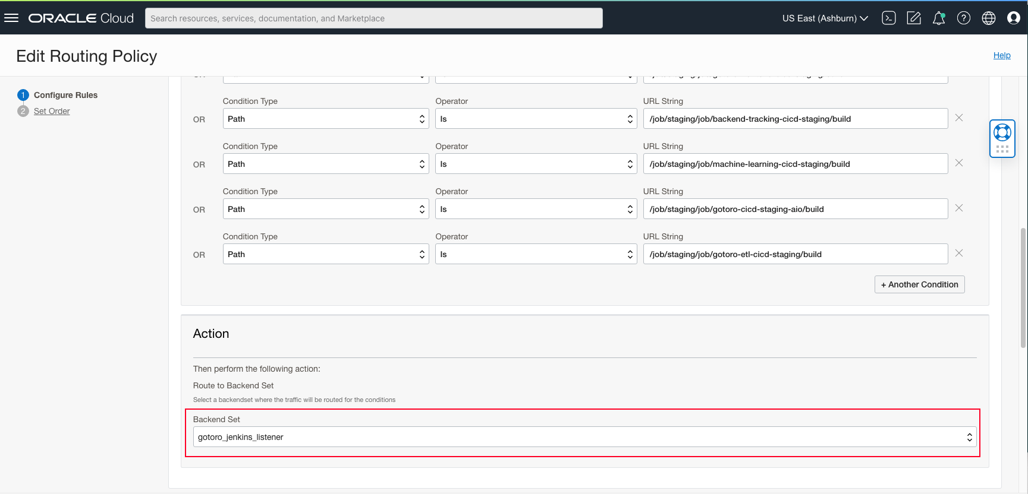

Step 5: Set order and Save Changes.

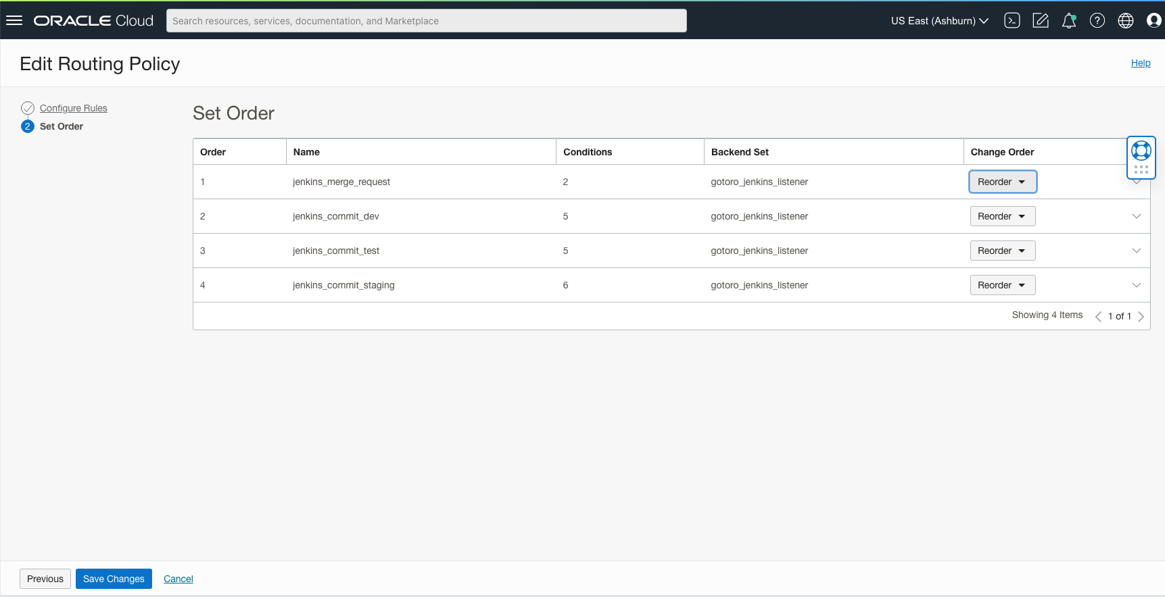

**End Guideline.**